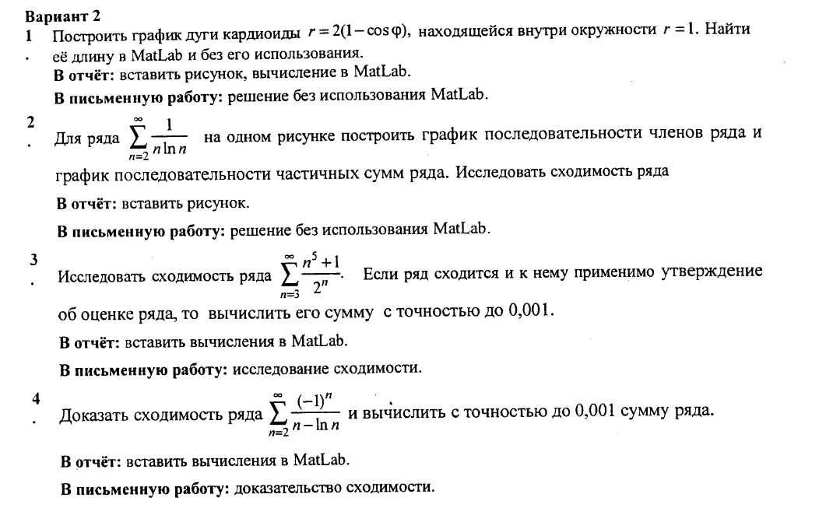

disp('---Task 1---')

figure(1)

t =0:pi/100:2\*pi;

t1=-1:0.01:1;

r=2\*(1-cos(t));

x=r.\*cos(t);

y=r.\*sin(t);

plot(x,y)

hold on

grid on

r1=1;

x1=r1.\*cos(t);

y1=r1.\*sin(t);

plot(x1,y1)

axis equal

syms t

r=2\*(1-cos(t));

l=int(( r^2 + (diff(r))^2)^(1/2),-pi/3,pi/3)

Command window

ans =

2.1436

